Learn material : CRM

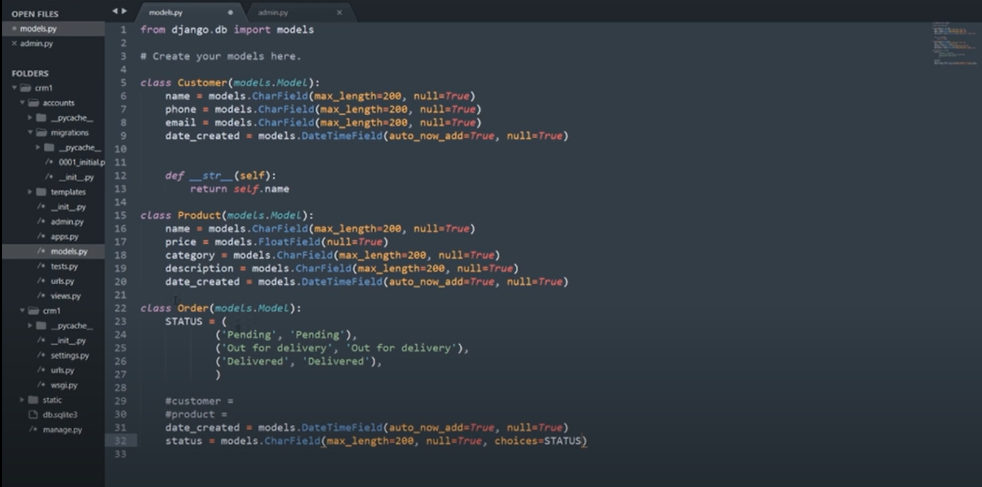

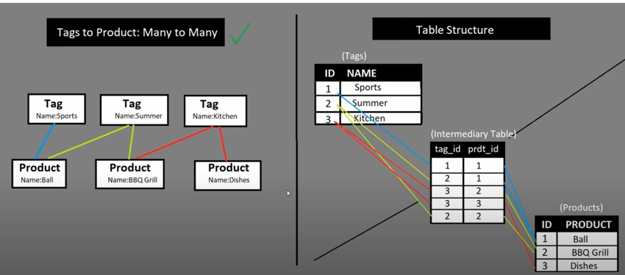

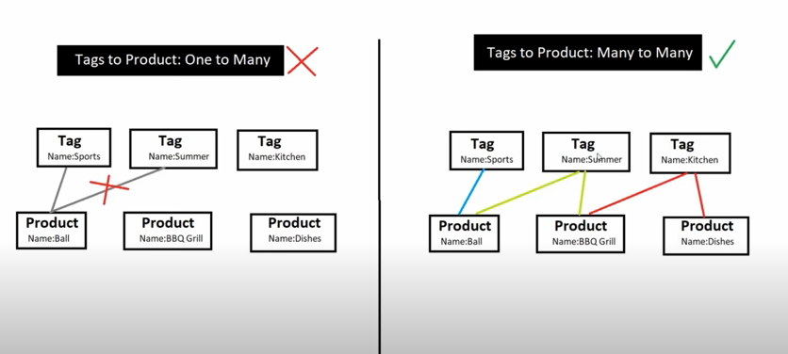

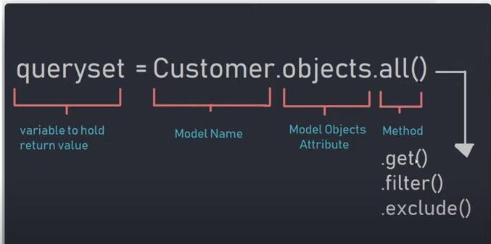

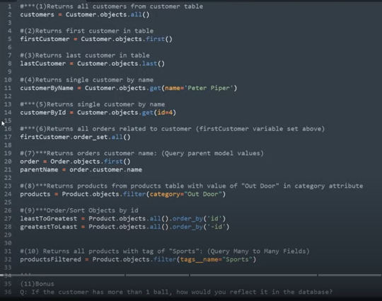

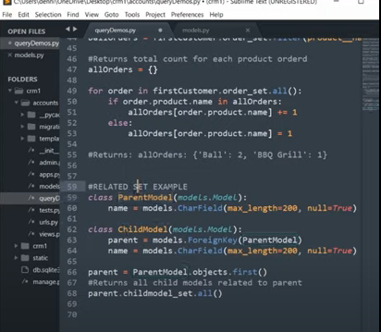

1. OrderFormSet = inlineformset_factory(Customer,Order,fields=('product','status'),extra=2)

#extra 10 is list more 10 rows in the form.

1. formset = OrderFormSet(queryset=Order.objects.none(),instance=customer)

#queryset=Order.objects.none() no record will show in form.

1. #form = OrderForm(initial={'customer':customer})

initial={'customer':customer}; ‘customer’ is datatype define in models whereas 2nd customer is referring to variable. Like customer = Customer.objects.get(id=pk).

1. Pip install django-filter:
   1. Register 'django_filters' to INSTALLED_APPS under setting.py.
2. Create filters.py file in same directory.
3. 